**Practical Task**

**Time: 120 minutes**

Create a Webpage as mentioned below and show your designing skills. You need to create a single webpage and by clicking on the menu header, navigate to that particular section.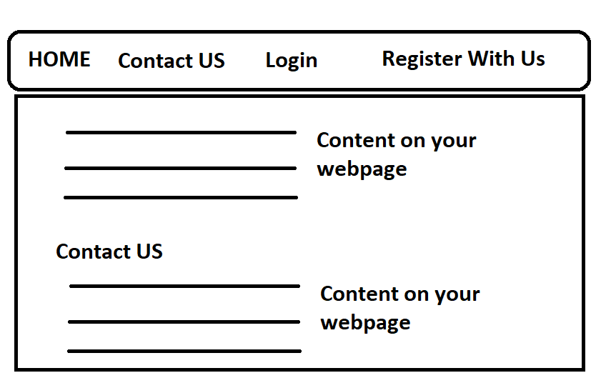

Add Proper validation on your login and Registration Page as mentioned below screenshots.

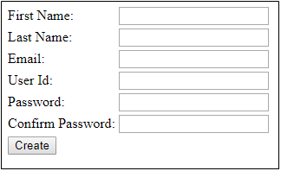

If we do not add any details and click on create, it should showcase us the below messages:

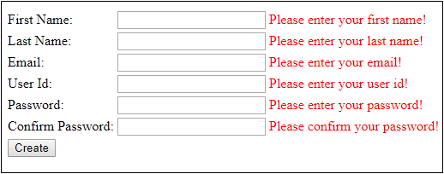

First Name, Last Name and User ID should be greater 3 alphabets and Password should be greater than 8 digit which will include at least 1 special character.

Entering proper value should display OK message and Email validation is required here:

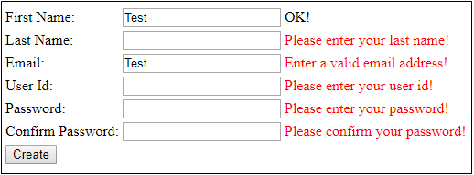

Make sure that passwords are match. This also a part of validation:

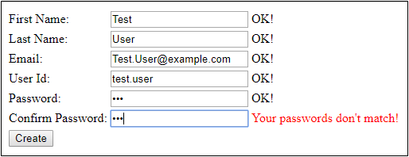

Final output – After clicking create, you should get a message “All the data you entered is correct”

